**Postman Outputs (Mentor on Demand)**

**Mentor Controller:**

[ Httpget ] get Skills:

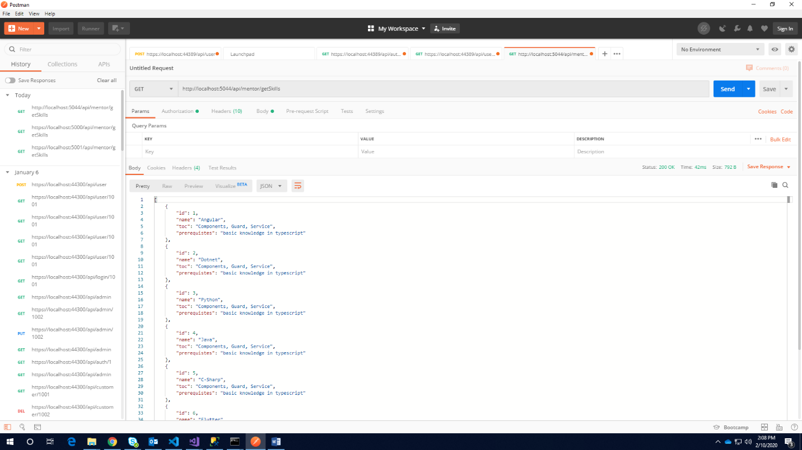

[ Httppost ]add Course:

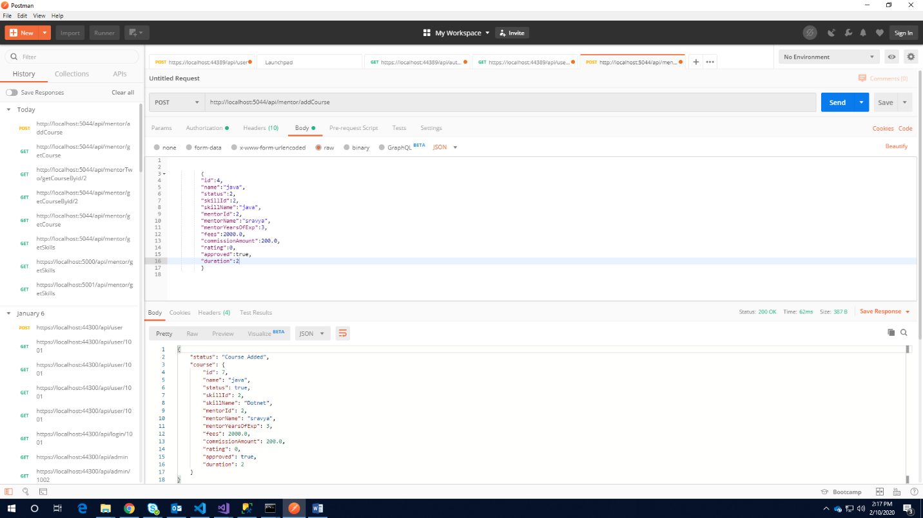

**MentortwoController**:

[Httpget] getCoursesById/id:

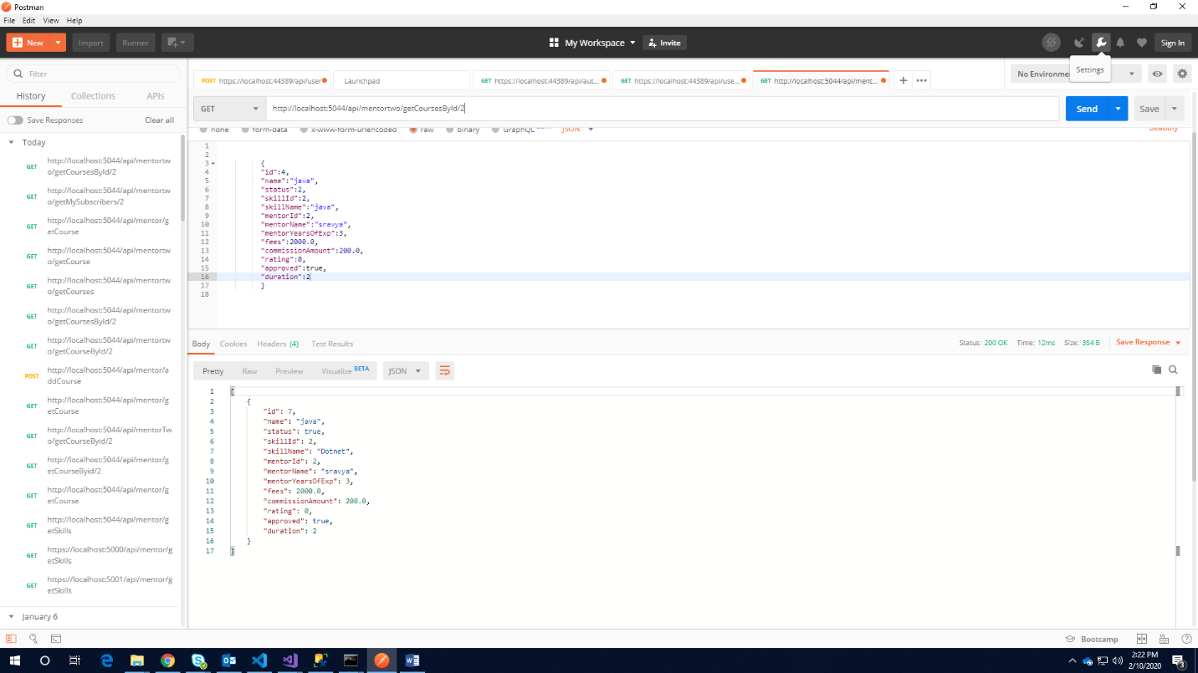

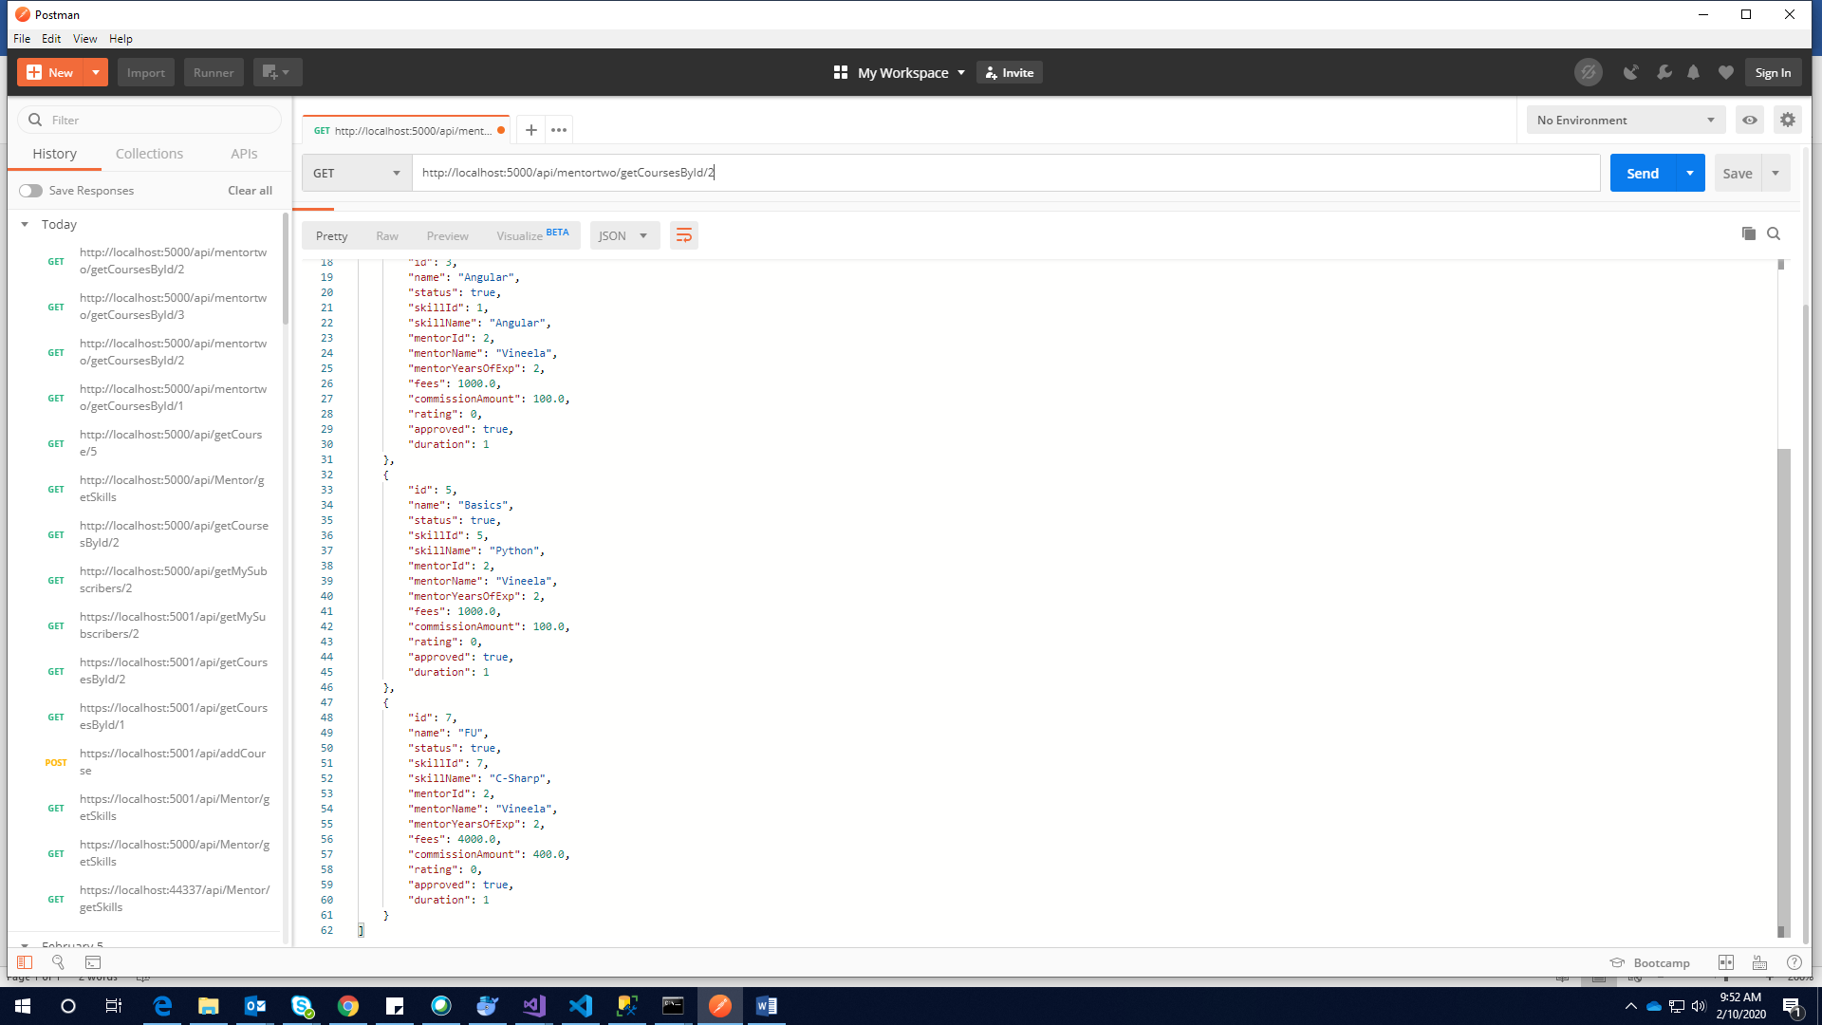

[Httpget] getCourse/2:

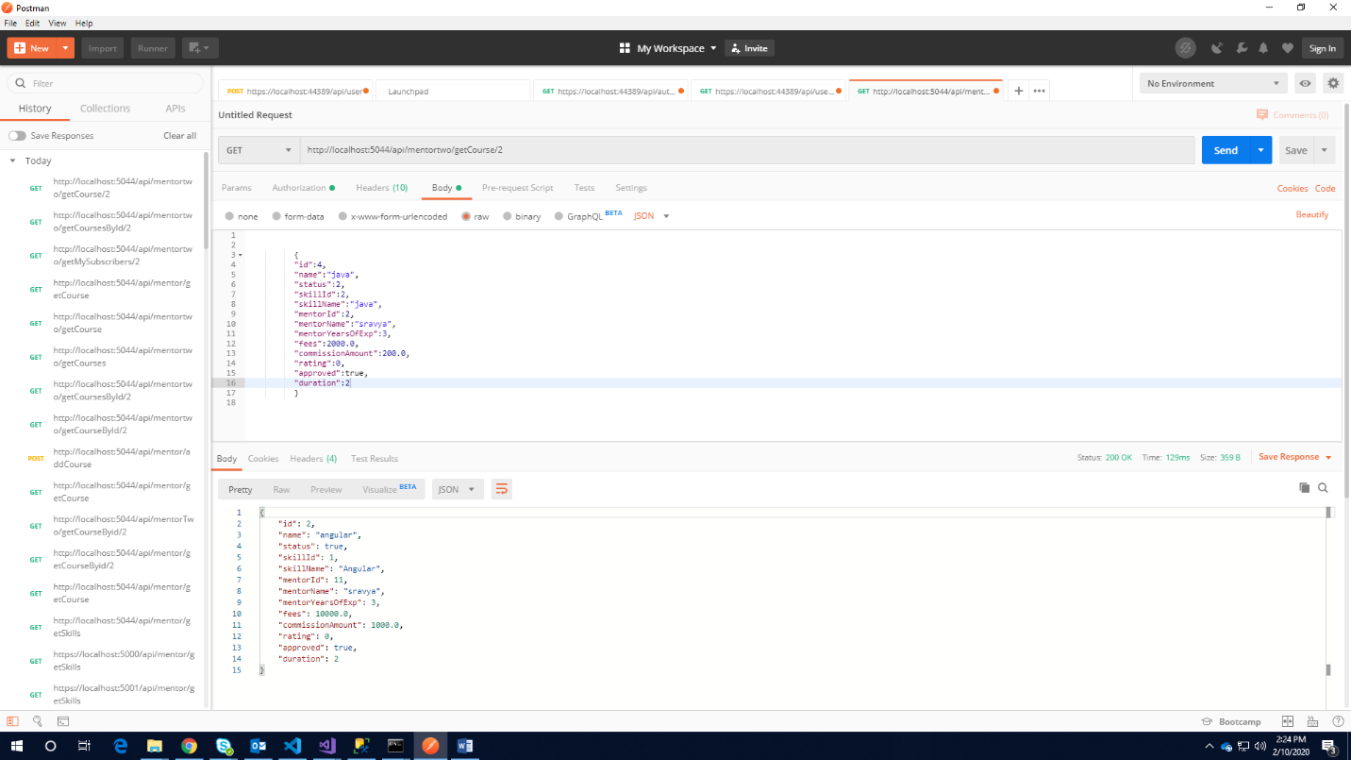

[httpget]getMySubscribers/2:

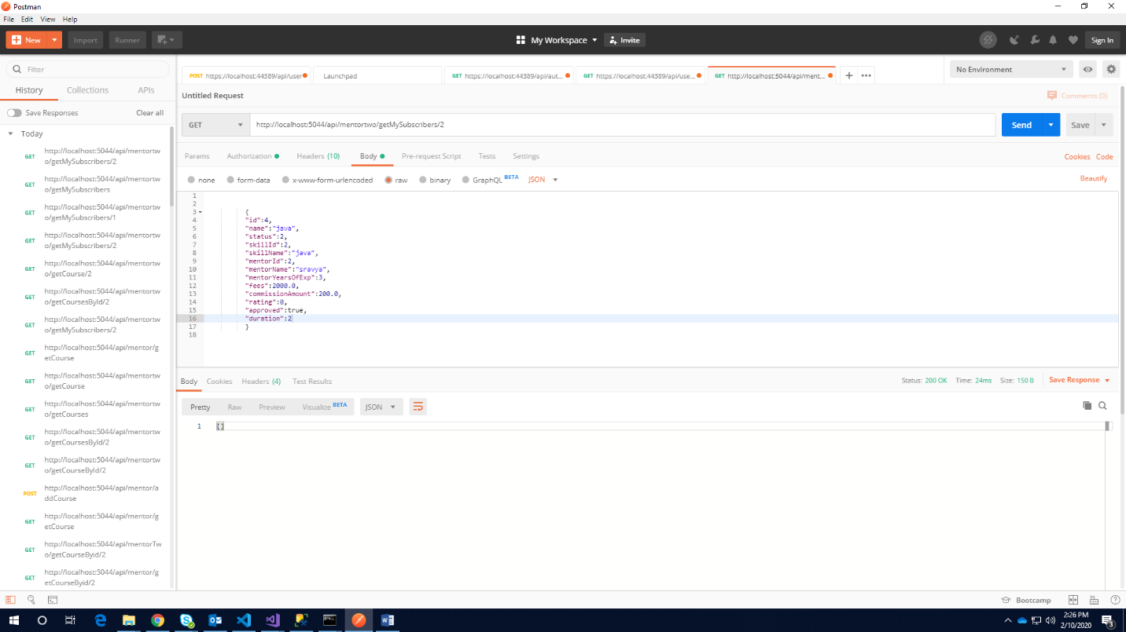

**userController**

[httpget] getCourses:

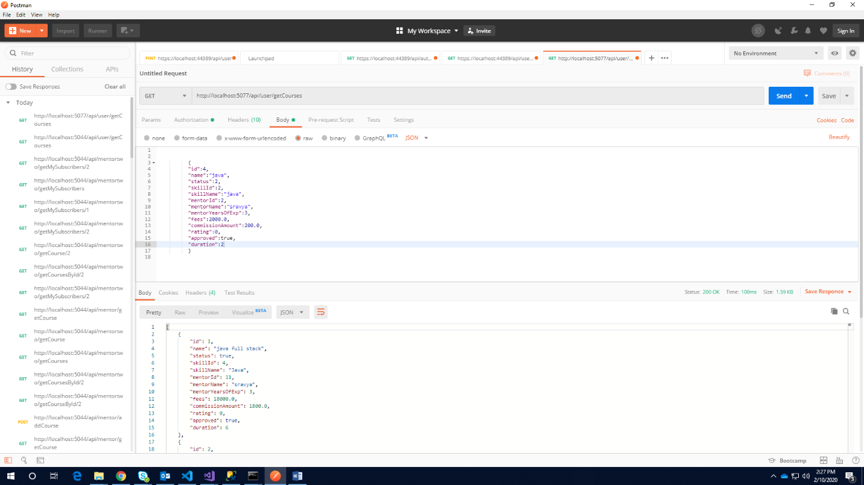

[httpget] getMyTrainings/id:

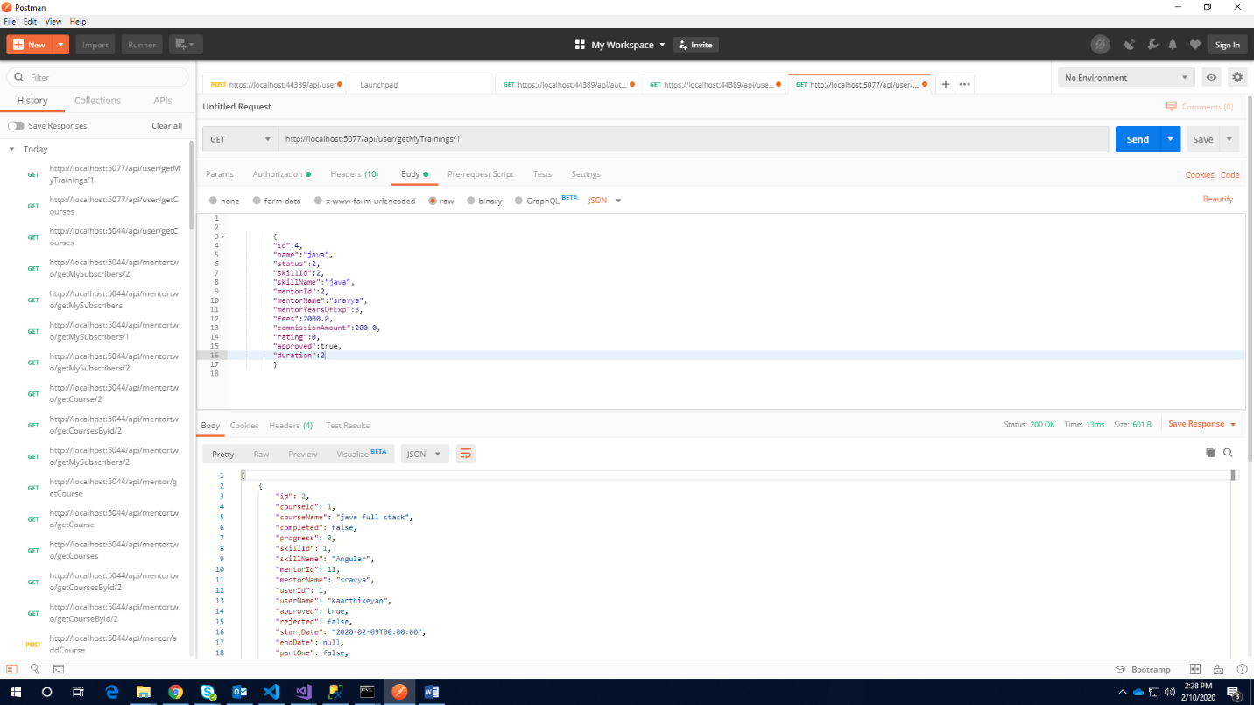

[httpget] getTraining/id:

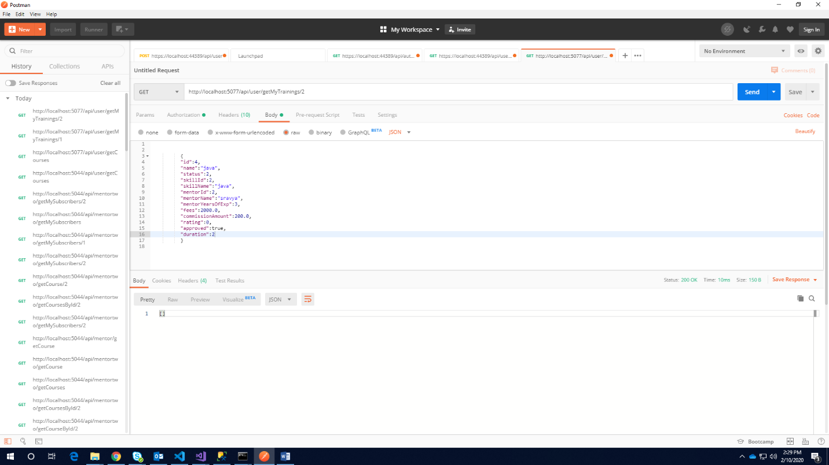

**AdminController**:

Post(addSkills):

es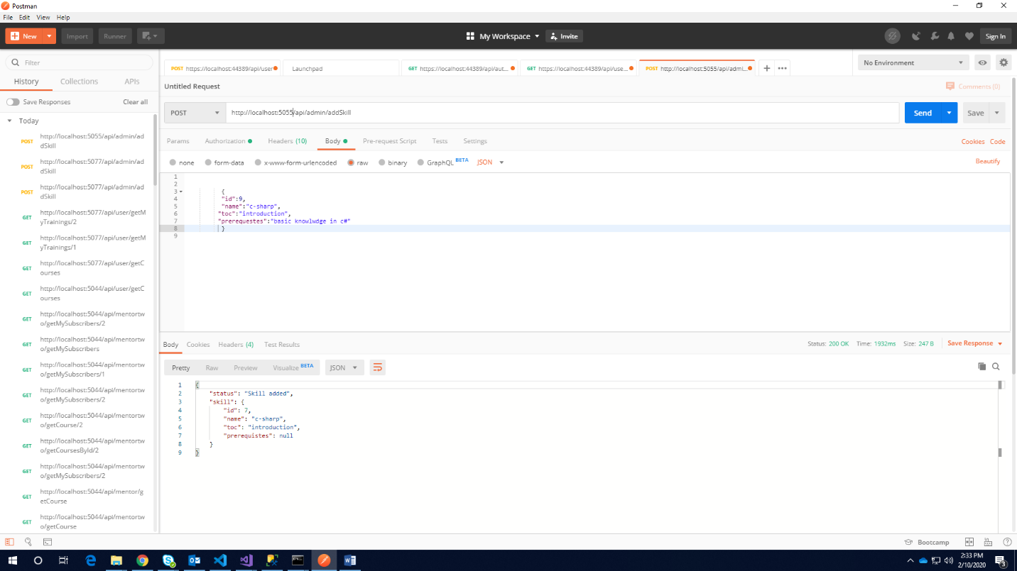

Delete(deleteSkill/id):

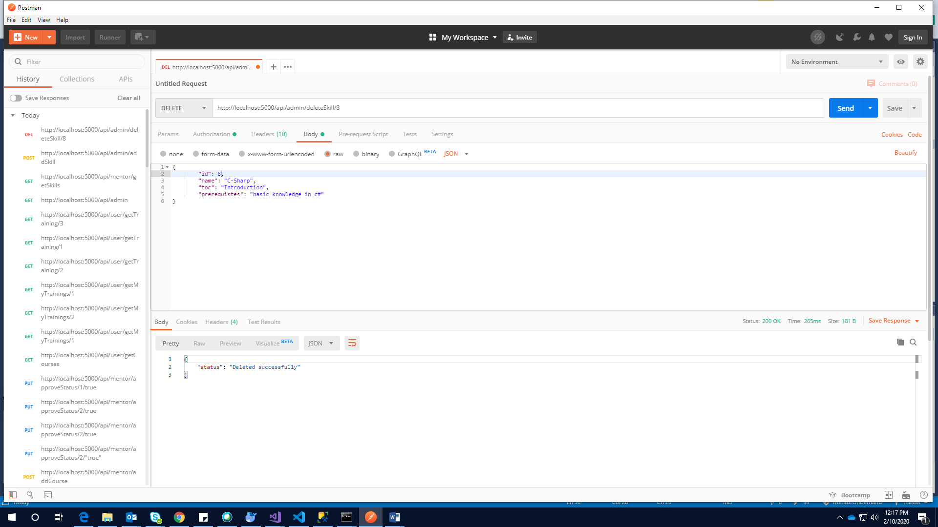

**Auth Controller**:

[httppost]login:

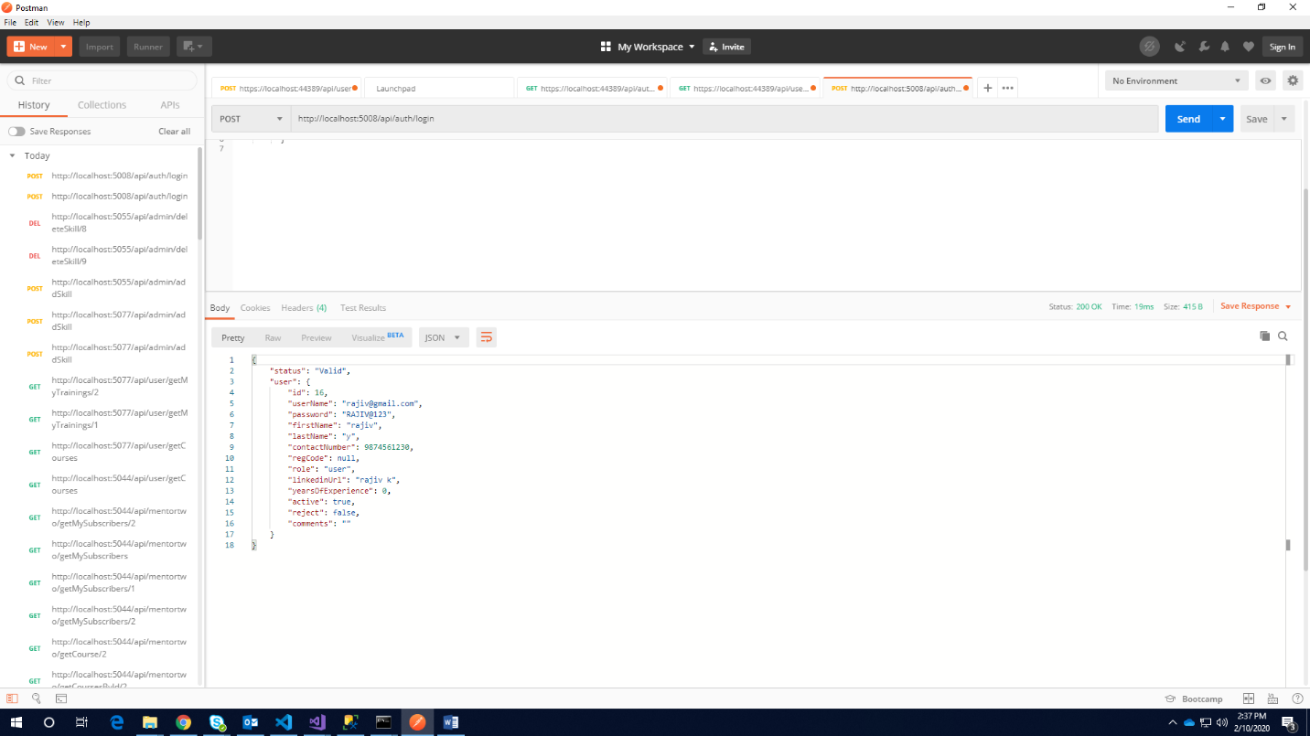

[httppost]Register:

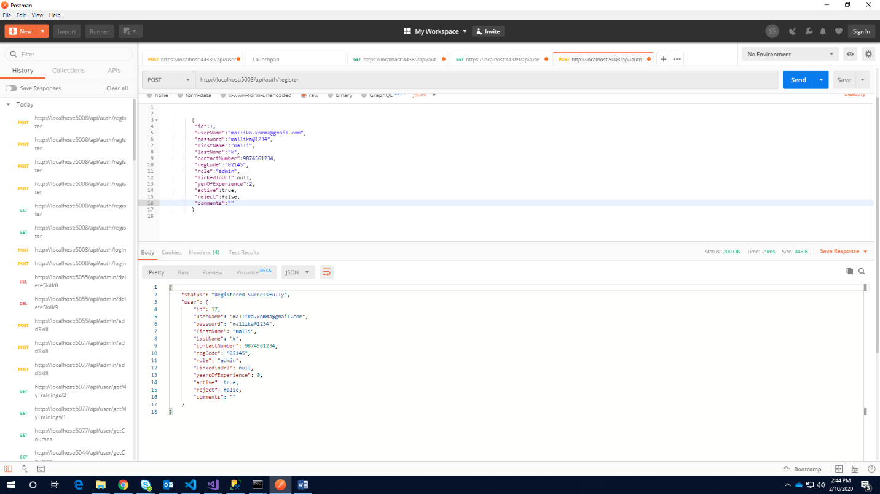

[httpget](checkUserName/rajiv@gmail.com)

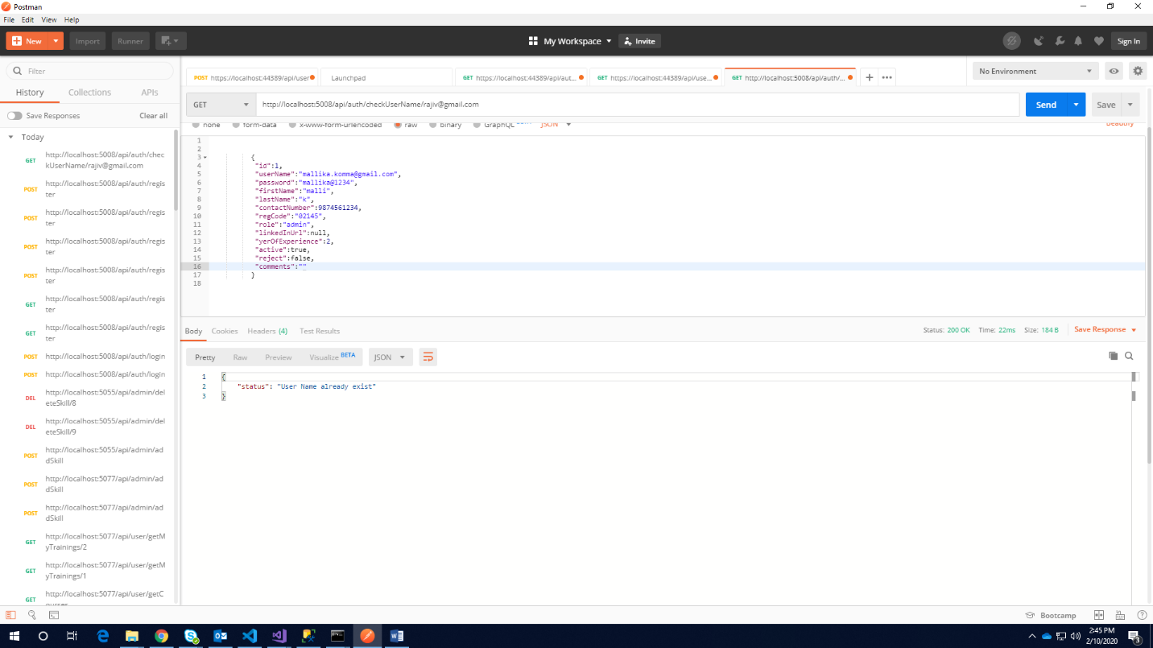

[httpget]Checking for Valid user name:

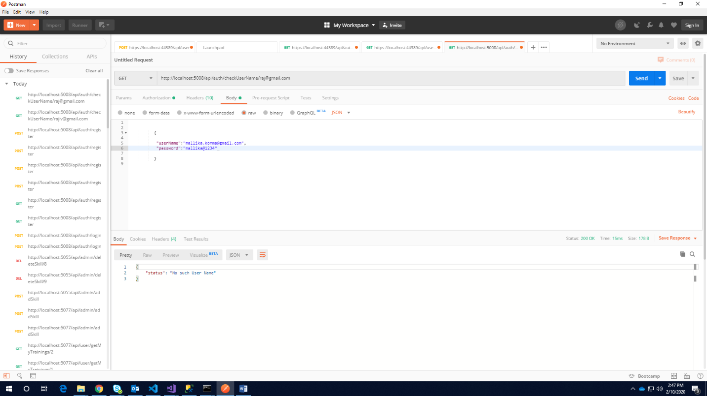

WEBFORMS OUTPUT

1. Home Page

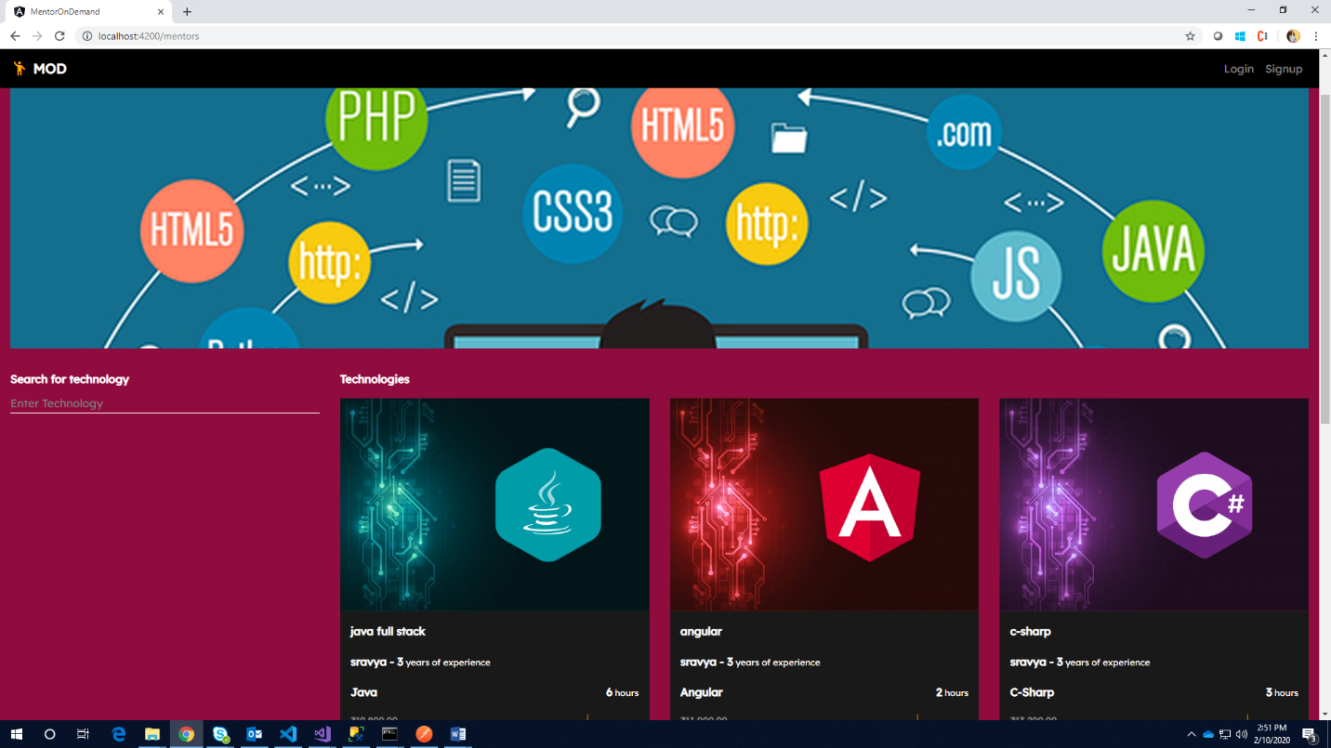

1. Registration Page for Mentor

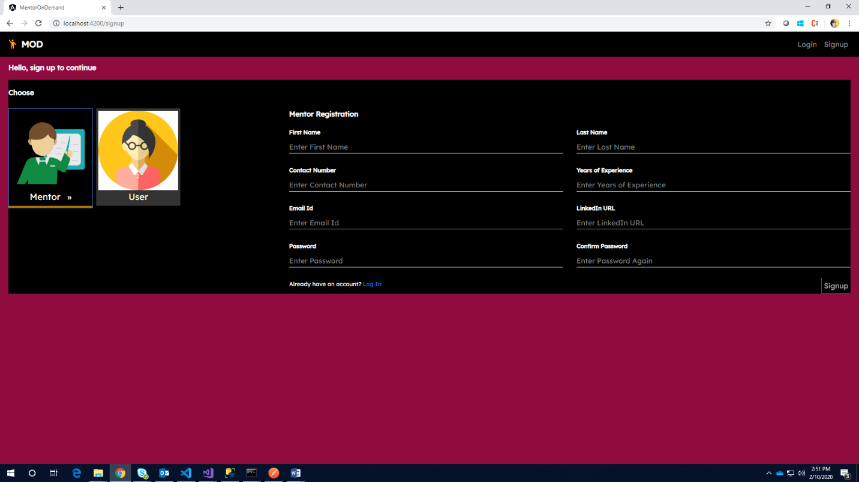

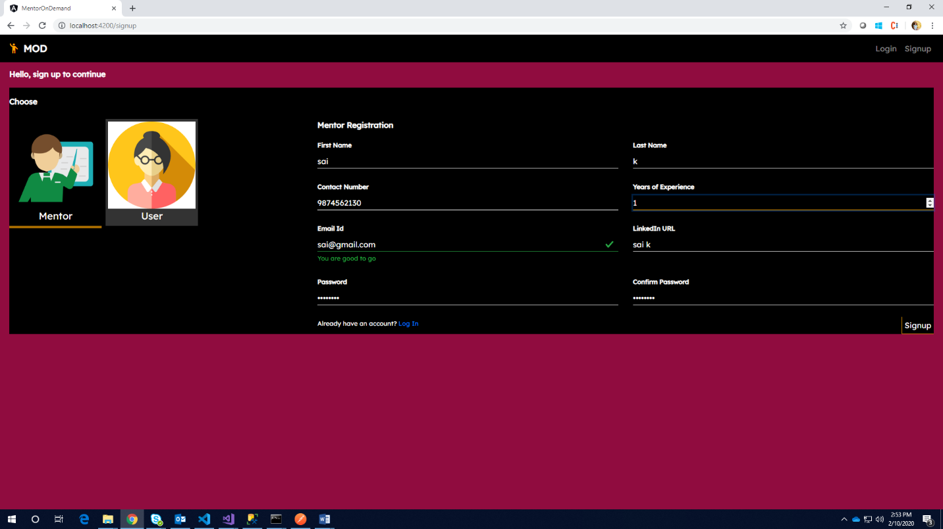

1. Registration page for User

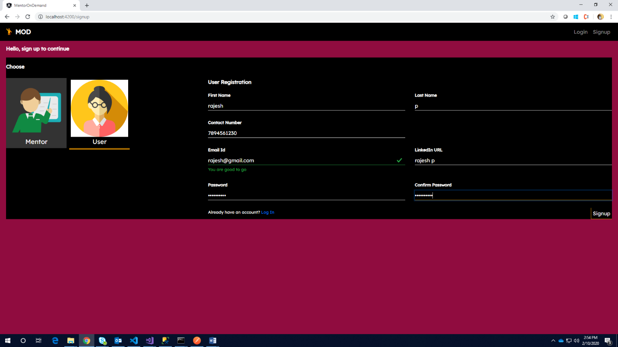

1. Login Page for Admin/Mentor/User

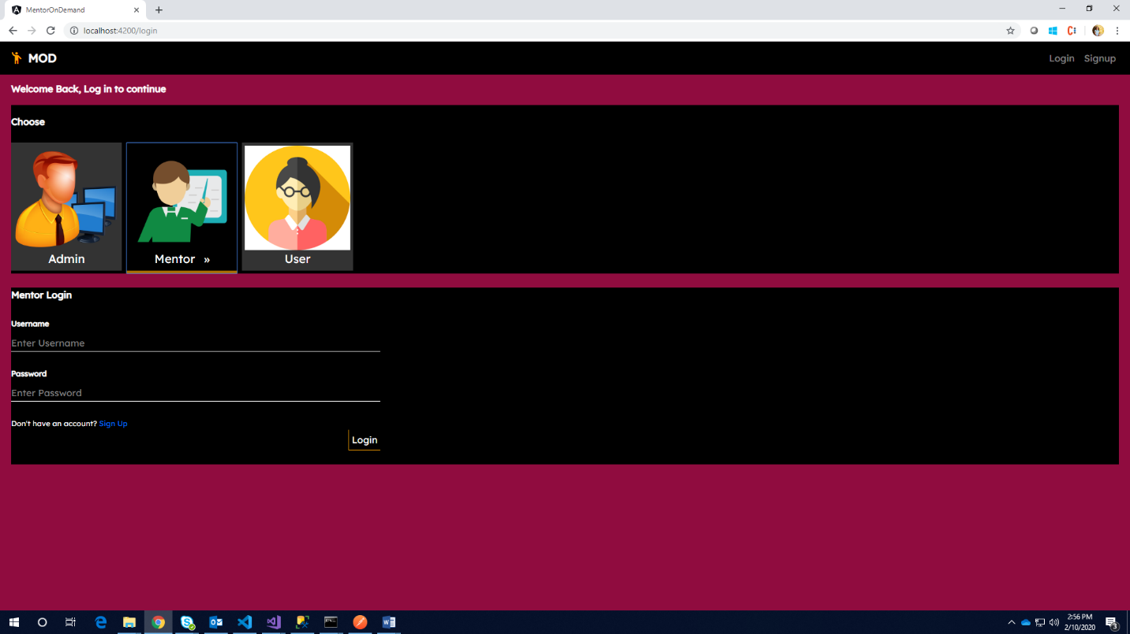

1. Mentor Page after Login

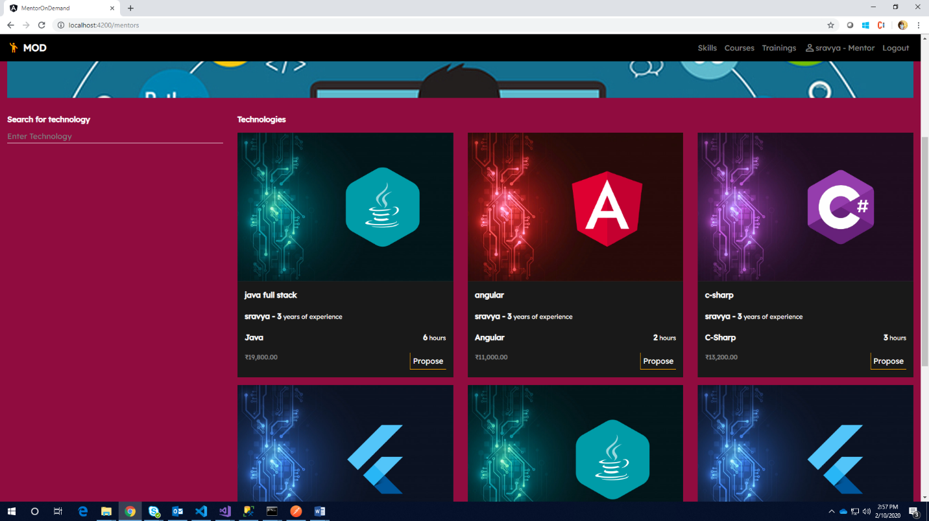

1. Mentor can add his skills

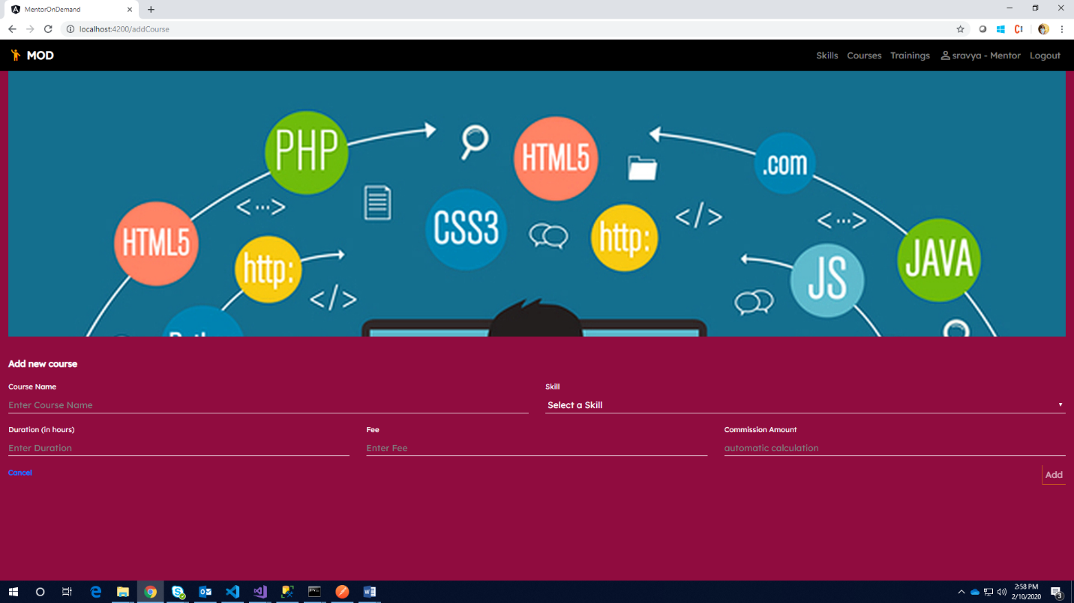

1. List of skills

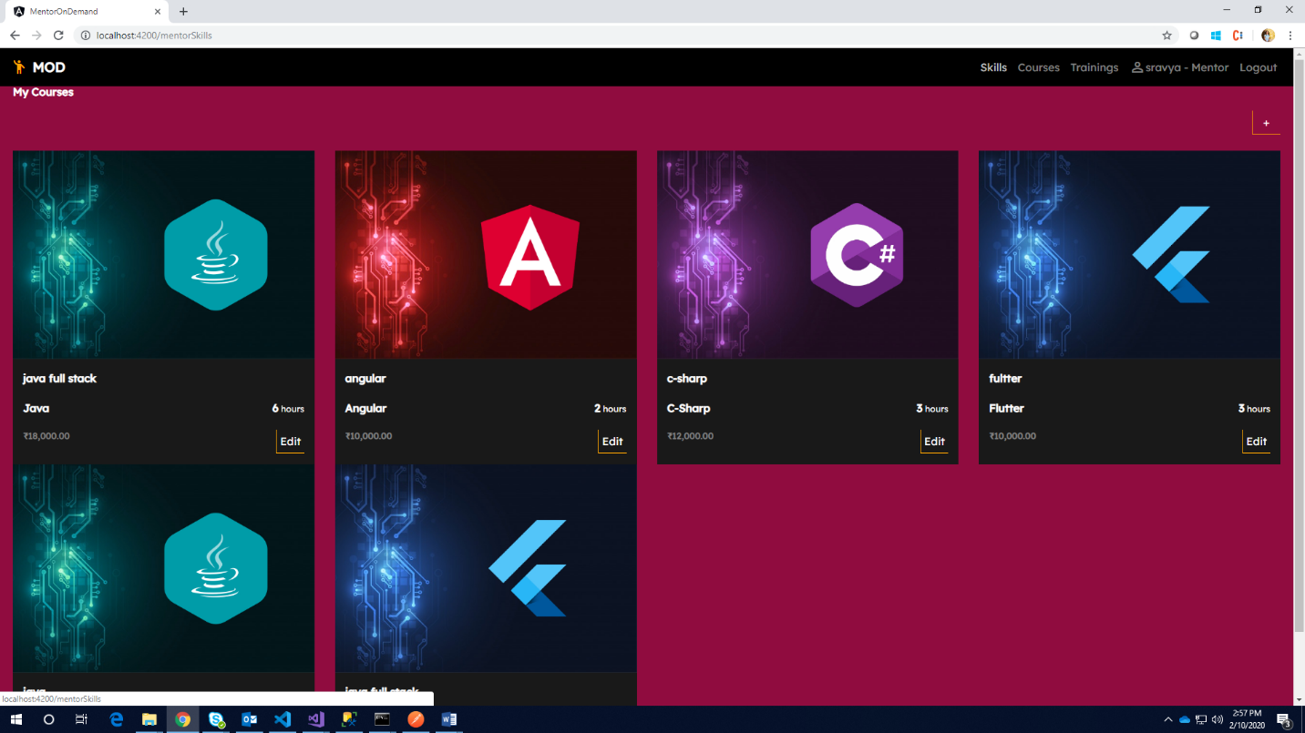

1. List of courses

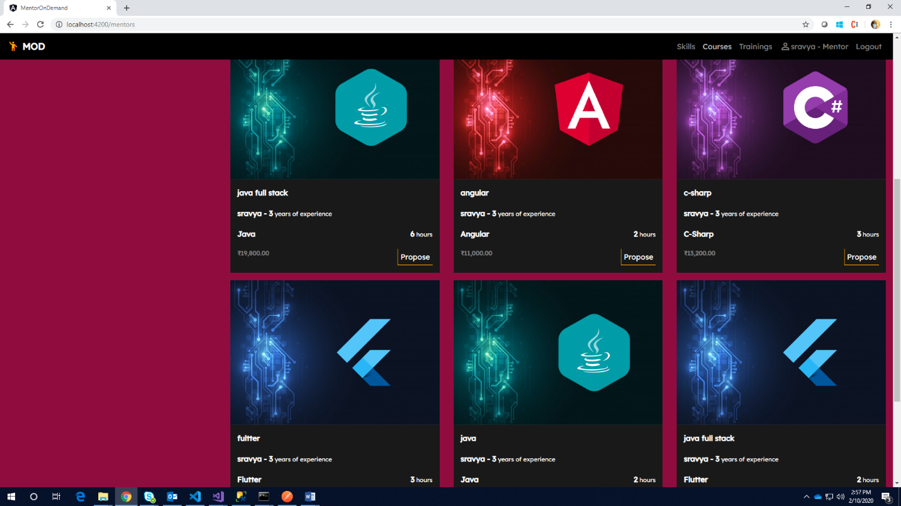

1. User Page after login

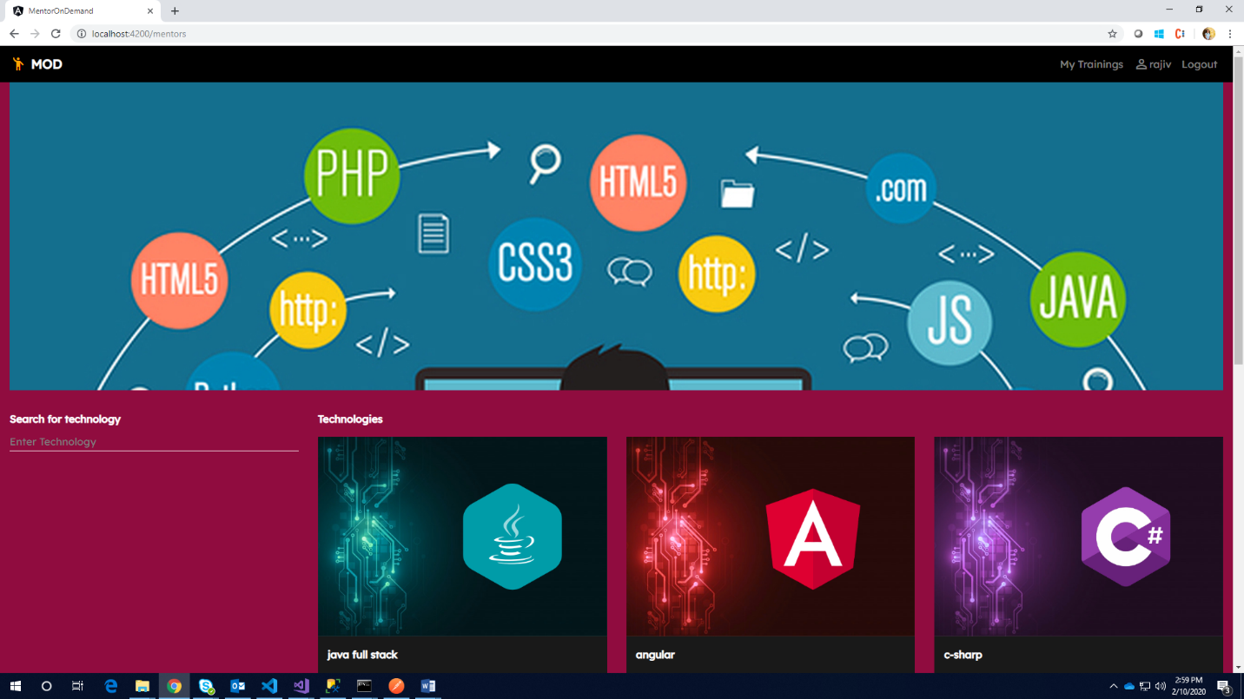

1. After Clicking on propose ,go to My Trainings

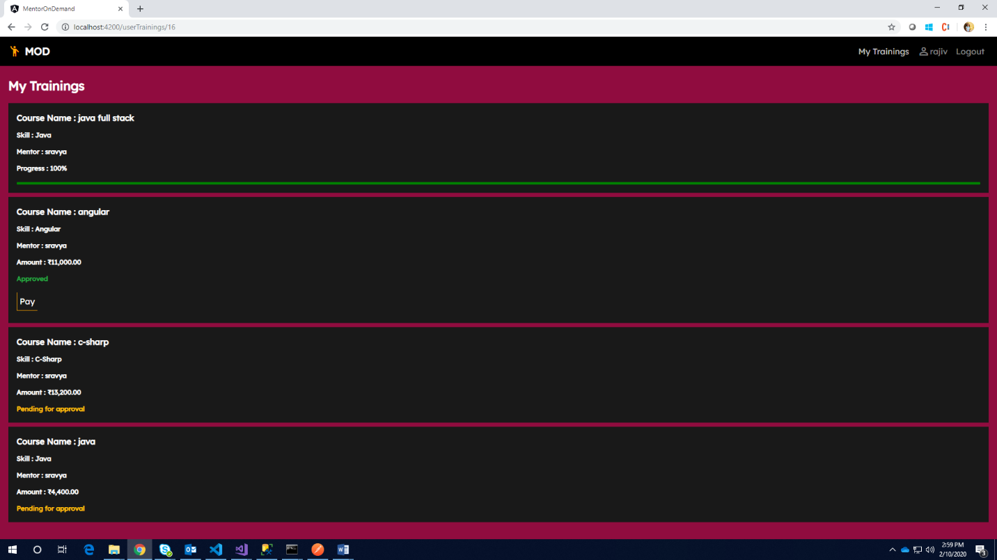

1. In Mentor Page , user proposed course will be displayed to particular mentor page

If she/he clicks on accept , reflects in user page

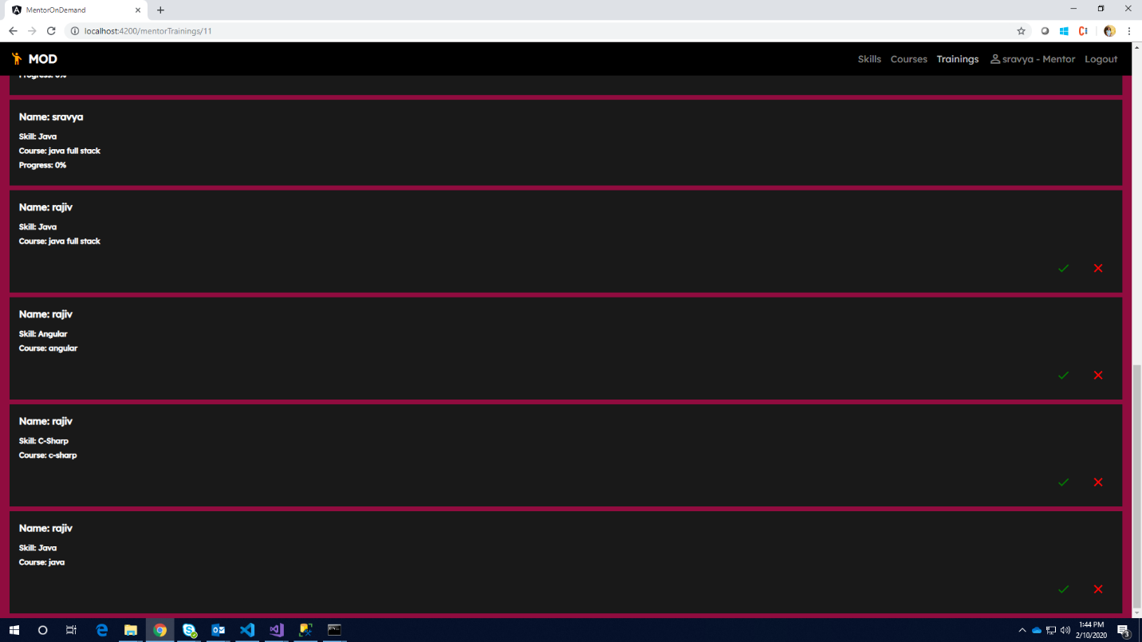

1. In user page ,you can see Approved message

Later he can proceed with payments

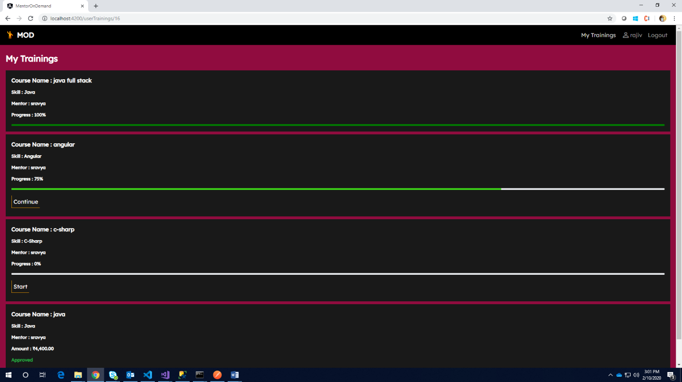

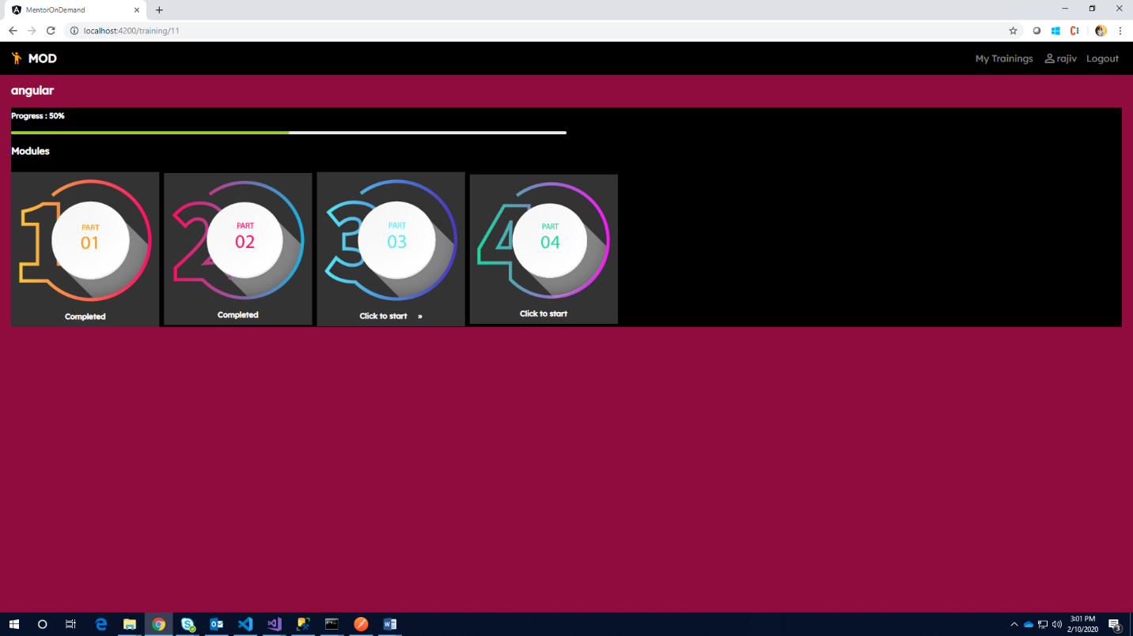

1. In Mentor page, Mentor can see user payment status

